Student Name | G. Manasa
Student Registration Number | 241U1R3007 | Class &Section: CSE-DS
Study Level: UG/PG | UG | Year &Term: II & I
Subject Name | Digital electronics

Name of the Assessment | Peer review class presentation
Date of Submission | 07-08-2025

PEER REVIEW OF CLASS PRESENTATION

Introduction:
This presentation is about logic gates which are basic building blocks o digital electronics logic gates are used in computers, calculators, smartphones and other digital systems they work using binary numbers only 0s and 1s and perform simple decision making tasks based on inputs.
The students explained the types of gates, their functions, and even how we can build complex gates using simple ones. I found it very interesting and useful, especially because logic gates are part of many entrance exams and also used in real-world electronics.

First Rishika explained about logic gates . And next they started explaining about basic logic gates there are three most basic gates AND, OR , NOT and also there are other important gates XOR Gate (Exclusive OR), XNOR Gate (Exclusive NOR)
And next pujitha explained about universal gates NAND Gate and NOR Gate also we discussed that why we call universal gate and next Meghana explained about Implementation of Logic Gates Using Universal Gates at last they explained about Discrete Component Implementation

- What Are Logic Gates?
- Logic gates are electronic circuits that perform logical operations.
- They use binary inputs (only 0s and 1s).
- Based on the input, they produce a specific output.
- These gates are very useful in building digital systems like processors, memory units, and many electronic control systems.

2. Basic Logic Gates
I learned about the three most basic gates:
AND Gate
Output is 1 only if all inputs are 1.
Like saying, Everything must be true.
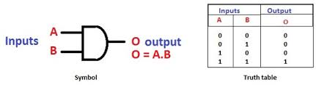
- OR Gate
Output is 1 if at least one input is 1.
Like saying, At least one should be true.
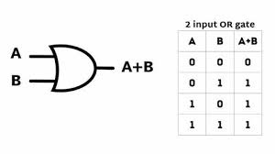
- NOT Gate
This gate gives the opposite value of the input.
If input is 1, output is 0 and vice versa.
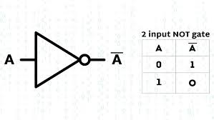
3. Other Important Gates
- XOR Gate (Exclusive OR)
Output is 1 only when the inputs are different.
If both inputs are same, output is 0.
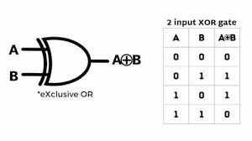
- XNOR Gate (Exclusive NOR)
Output is 1 only when inputs are same.
It is the opposite of XOR gate.
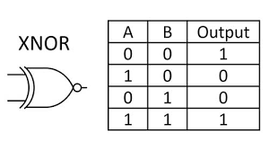
These gates are used in more complex circuits like adders, comparators, etc.

4. Universal Gates
The presentation also taught me about Universal Gates:
- NAND Gate
Combines AND + NOT
Output is opposite of AND gate.
- NOR Gate
Combines OR + NOT
Output is opposite of OR gate.
Why are they called Universal?
Because using only NAND or NOR gates, we can make all other gates like AND, OR, NOT, XOR, and XNOR.
This is useful in real-world circuit design where only one type of gate may be available due to cost or space.

5. Implementation of Logic Gates Using Universal Gates
They explained about NOT gate using Nor gate and OR gate using NOR gate and next AND gate using NOR gate and NAND gate using Nor gate
The most interesting part was seeing how:
- AND, OR, NOT gates can be made using only NAND or only NOR gates.
- Even XOR and XNOR can be created using just universal gates.
This showed how flexible digital design can be. The presentation showed the circuits, equations, and logic diagrams clearly for each gate.

6. Discrete Component Implementation
The last slide mentioned using discrete components to create logic gates.
This means using basic electronics like resistors, transistors, and switches to build gates from scratch not just using IC chips.

Conclusion:
This presentation helped me clearly understand logic gates both their theory and practical use. I now know how different gates work and how they can be combined to form complex circuits. I also learned the importance of universal gates in building any digital system.

